Mobile Application Security Testing Lab Report
Using MobSF, Frida, and Drozer

1. Introduction
Mobile applications frequently handle sensitive user data such as credentials, personal information, and financial details. Improper security controls can expose applications to serious vulnerabilities.
This lab focuses on identifying and exploiting security weaknesses in an Android application using static analysis, dynamic analysis, and IPC testing techniques.
The vulnerable application InsecureBankv2 was analyzed using industry-standard tools:
- Mobile Security Framework (MobSF)
- Frida
- Drozer

2. Objective
The objectives of this lab were:
- To perform static analysis on an Android APK using MobSF.
- To identify insecure storage vulnerabilities.
- To conduct dynamic analysis and bypass authentication using Frida.
- To analyze exported components and IPC vulnerabilities using Drozer.
- To document findings and assess application security posture.

3. Lab Environment
Operating System
- Kali Linux (Running on VMware Workstation)
Software & Tools
- MobSF v4.4.4
- Python 3.13
- Poetry 2.3.1
- Frida
- Drozer
- Android Emulator (Genymotion/AVD)
- ADB
Target Application
- Application Name: InsecureBankv2
- APK Name: test.apk
- Package Name: com.android.insecurebankv2

4. MobSF Installation and Setup
MobSF was installed from the official GitHub repository. Dependency management was handled using Poetry, which ensured a clean and isolated Python environment.
After successful installation, MobSF was launched locally and made accessible through the browser at:
http://127.0.0.1:8000
A superuser account was created using the Django management command to enable full access to MobSF features.
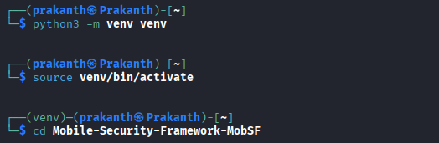
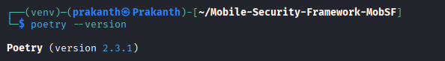
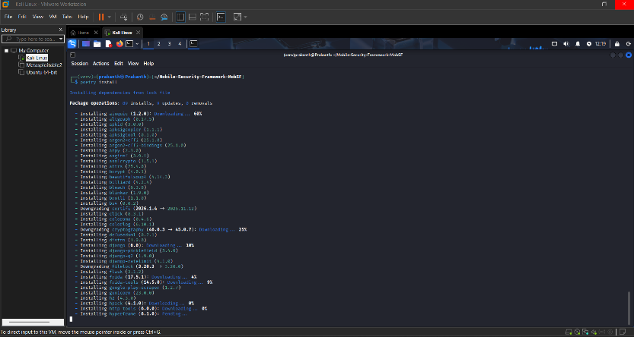
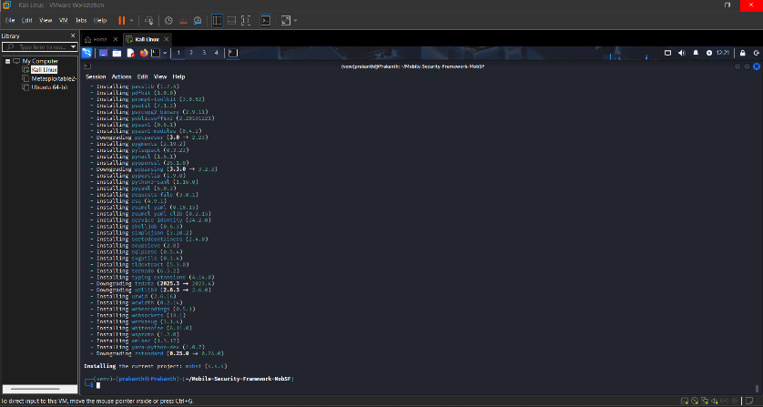
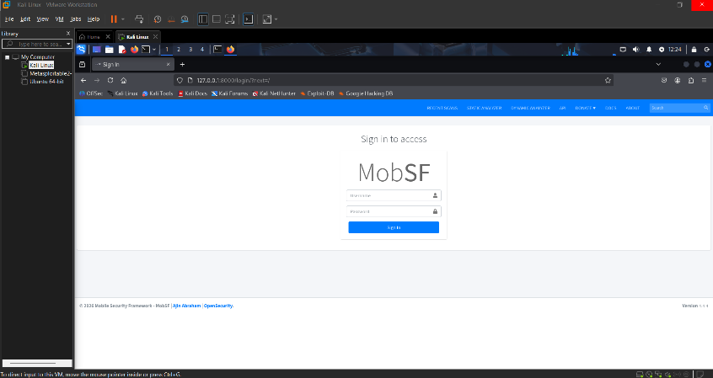
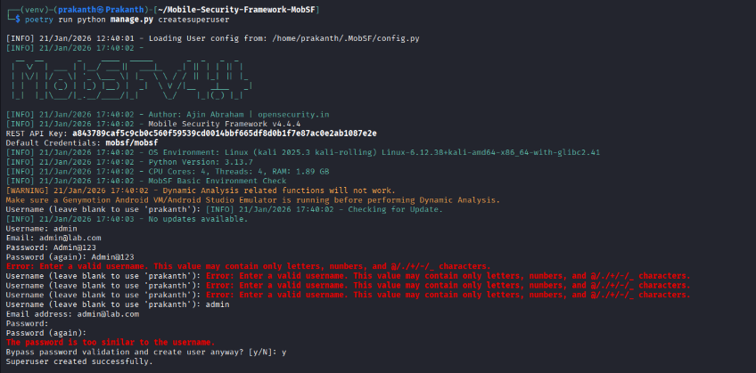
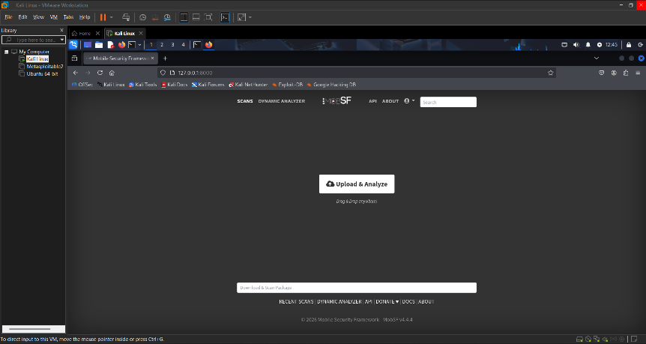

5. Static Analysis Using MobSF
5.1 APK Upload
The vulnerable APK (test.apk) was uploaded through the MobSF web interface. MobSF automatically initiated static analysis upon upload.
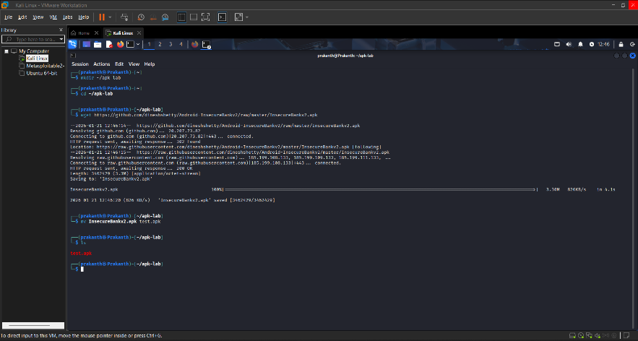

5.2 File and Application Information
MobSF extracted detailed metadata from the APK, including:
- Application name
- Package name
- Android SDK versions
- Hashes (MD5, SHA1, SHA256)
- Application size
This information helps verify APK integrity and supports further forensic analysis.

5.3 Security Score
- Security Score: 28 / 100
- Trackers Detected: 3 / 432
The low security score indicates poor security implementation and the presence of multiple vulnerabilities.

5.4 Exported Components Analysis
MobSF identified several exported components:
- Exported Activities: 4 / 10
- Exported Receivers: 1 / 2
- Exported Providers: 1 / 1
- Exported Services: 0 / 0
Exported components without proper permission checks can be abused by malicious applications to access sensitive functionality.

5.5 Insecure Storage Findings
MobSF revealed insecure storage vulnerabilities, including:
- Sensitive data stored in plaintext
- Usage of insecure shared preferences
- Potential storage of credentials without encryption
- World-readable or improperly protected files
These vulnerabilities could allow attackers with device access to retrieve sensitive information.
Severity: High
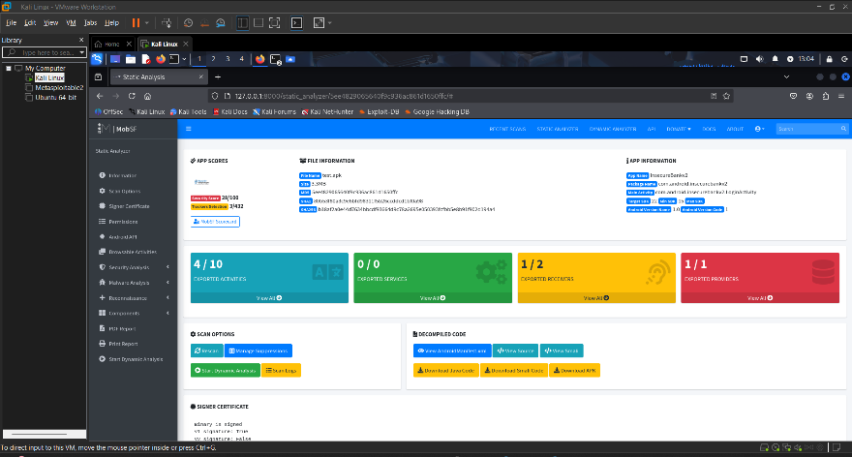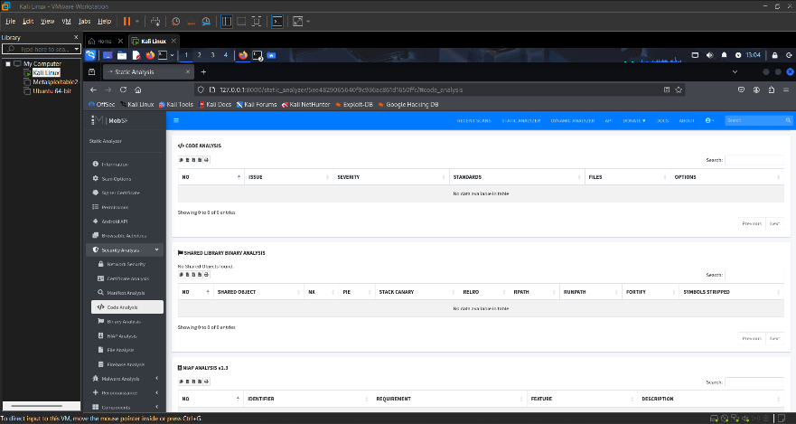

6. Dynamic Analysis Using Frida
6.1 Frida Setup
Frida was installed on the Kali host, and the matching Frida server binary was deployed to the Android emulator. The Frida server was executed with appropriate permissions.
Connectivity was verified using:
frida-ps -U
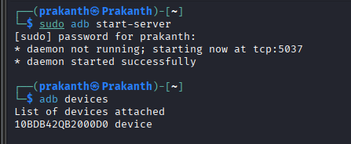
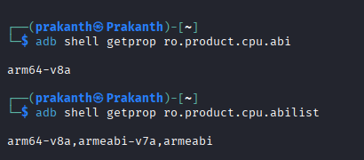
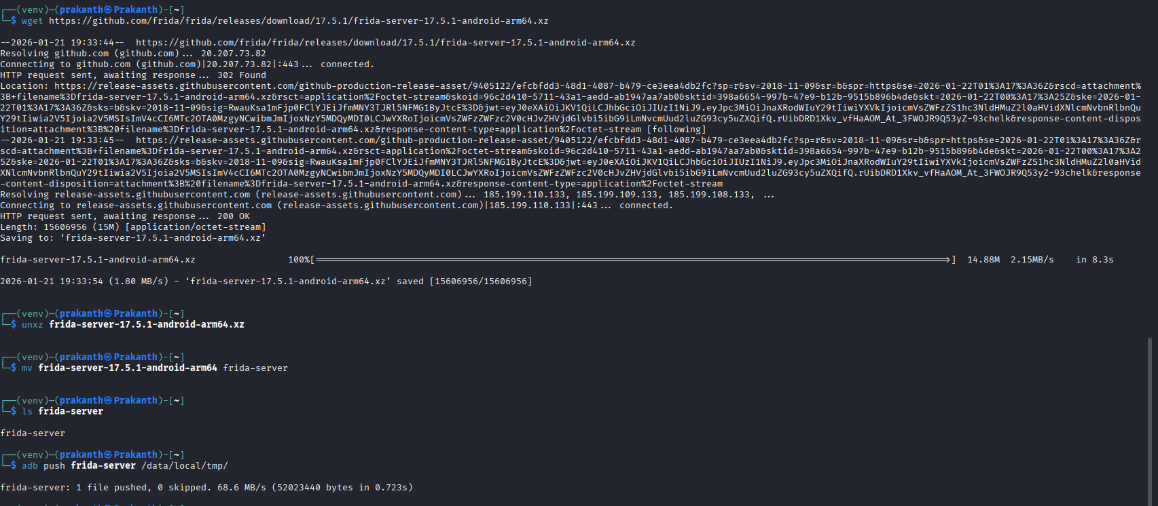
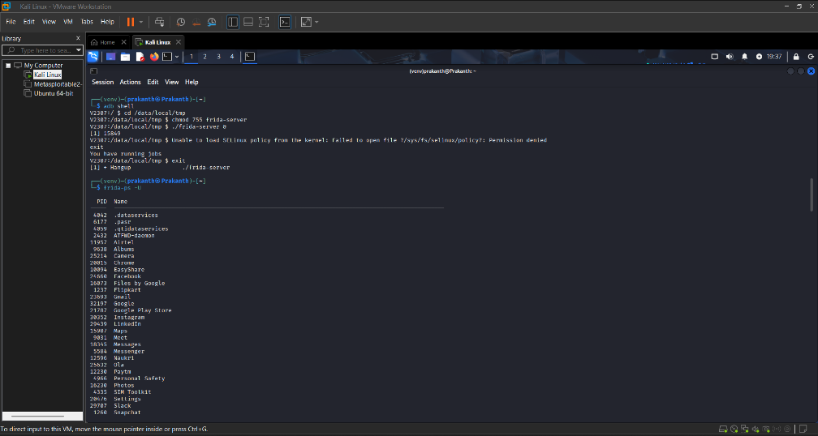
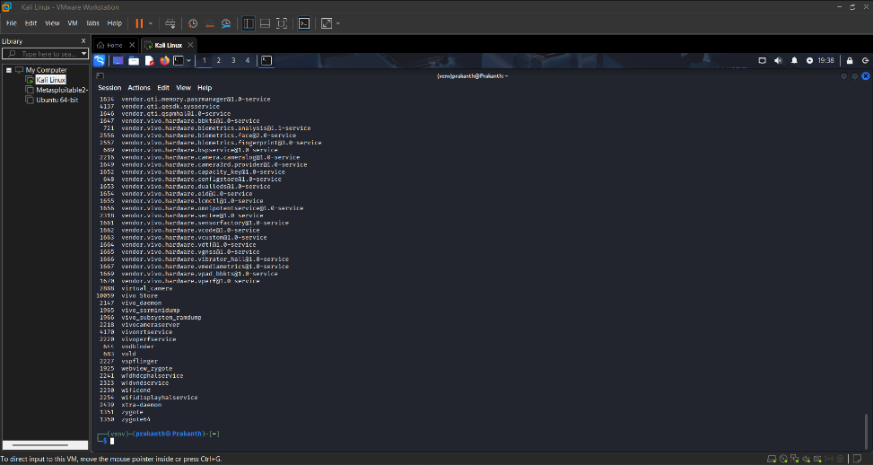

6.2 Authentication Bypass
Using reverse engineering and function hooking, the application’s authentication mechanism was targeted.
A Frida JavaScript hook was created to override the login validation function and force it to always return true.
This resulted in:
- Successful login without valid credentials
- Complete authentication bypass
Impact:
An attacker could gain unauthorized access to the application and sensitive user data.
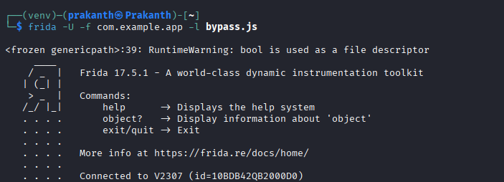
7. IPC and Component Testing Using Drozer
7.1 Drozer Setup
The Drozer agent was installed on the Android emulator, and port forwarding was configured to allow communication between Kali Linux and the device.
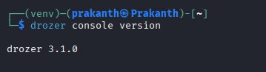
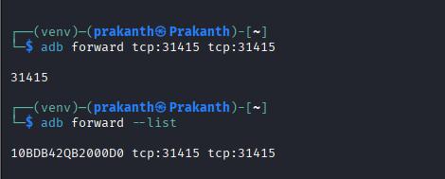

7.2 Package and Component Enumeration
Drozer was used to enumerate:
- Application package information
- Exported activities
- Content providers
- Services

7.3 Exploiting Exported Components
Drozer confirmed that certain activities could be launched externally without authentication.
This allows attackers to:
- Access internal application screens
- Trigger sensitive actions
- Bypass normal application flow
Severity: Medium to High

8. Summary of Vulnerabilities
Vulnerability | Tool Used | Severity
Insecure Storage | MobSF | High
Exported Activities | MobSF / Drozer | Medium
Authentication Bypass | Frida | Critical
Improper IPC Controls | Drozer | Medium

9. Conclusion
This lab demonstrated how insecure coding practices can expose Android applications to serious security risks. Static analysis using MobSF revealed insecure storage and exported components. Dynamic analysis with Frida successfully bypassed authentication mechanisms, while Drozer confirmed IPC vulnerabilities.
The application is highly vulnerable and requires significant remediation to meet secure development standards.

10. Recommendations
- Encrypt all sensitive data stored locally
- Implement proper permission checks for exported components
- Enforce strong authentication and server-side validation
- Apply secure coding practices and regular security testing
- Use ProGuard or R8 for code obfuscation

11. Summary
Static analysis using MobSF identified insecure storage and exported components in the Android application. Dynamic testing with Frida successfully bypassed authentication mechanisms. Drozer analysis confirmed IPC vulnerabilities. These findings indicate poor security implementation, emphasizing the need for secure storage, access controls, and robust authentication.

